MEETING A COLLEAGUE IN MDP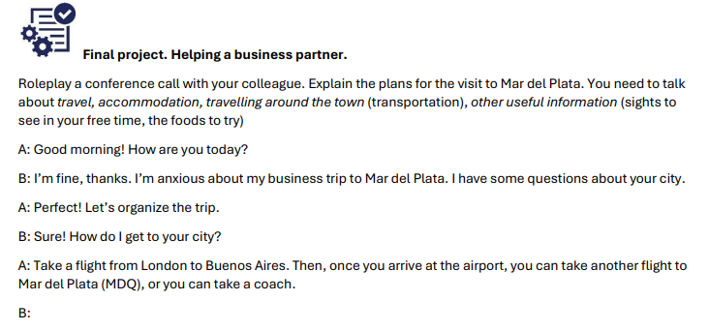

1. Vocabulario de Viajes (Unificado)
A. Verbos y Acciones:
- To hire a vehicle: Alquilar un vehículo.
- To pack a suitcase: Hacer la maleta.
- To stay: Alojarse / quedarse en un lugar.
- To travel abroad: Viajar al extranjero.
- To take (a flight/a train): Tomar (un vuelo / un tren).
B. Medios de Transporte y Vuelos:
- Flight: Vuelo.
- Vehicle: Vehículo.
- Coach: Micro de larga distancia.
- Public transportation / Public transport: Transporte público.
- Ridesharing app: Aplicación de transporte (ej. Uber, Cabify).
- Long-haul: De larga distancia (usualmente vuelos intercontinentales).
- Short-haul: De corta distancia (vuelos regionales).
- Take-off / Landing: Despegue / Aterrizaje.
- On-time / Delayed: A horario / Demorado.
C. Alojamiento:
- Reservation: Reserva.
- Stay: Estancia (o la acción de quedarse en un lugar).
- Location: Ubicación.
- Budget hotel: Hotel económico.
- Business hotel: Hotel para viajes de negocios.
- Luxury hotel: Hotel de lujo.
- Youth hostel: Albergue juvenil.
- Bed and breakfast (B&B): Alojamiento con desayuno incluido.
- Rented apartment: Departamento alquilado.
- Holiday resort: Complejo vacacional.
D. Infraestructura y Otros:
- Abroad: En el extranjero.
- Gate: Puerta de embarque.
- Lounge / Departure lounge: Sala de espera / Sala de pre-embarque.
- Local (food/customs): Local (comida / costumbres del lugar).

2. Preguntas Disparadoras (Unificadas)
Utiliza estas preguntas para mantener el diálogo activo durante tu examen oral:
- Transport: Do you prefer to hire a vehicle or use public transport when you visit a new city? (¿Prefieres alquilar un auto o usar transporte público?)
- Transport: How do you usually travel when you are on a business trip? (¿Cómo sueles viajar cuando estás en viaje de negocios?)
- Accommodation: What is more important for you: a luxury hotel or a perfect location near the city centre? (¿Qué es más importante para ti: un hotel de lujo o una ubicación perfecta cerca del centro?)
- Accommodation: Do you prefer staying in a hotel or in an apartment? (¿Prefieres quedarte en un hotel o en un departamento?)
- Flight details: Have you ever had a long-haul flight? Was it tiring? (¿Alguna vez hiciste un vuelo de larga distancia? ¿Fue cansador?)
- Experiences: When you travel abroad, do you prefer to try local food or go to familiar restaurants? (Cuando viajas al extranjero, ¿prefieres probar comida local o ir a restaurantes conocidos?)
- Preparation: How early do you arrive at the airport before your departure? (¿Con cuánta anticipación llegas al aeropuerto antes de tu salida?)
- Packing: Are you good at packing your suitcase, or do you always forget something? (¿Eres bueno empacando tu maleta o siempre olvidas algo?)
- Sightseeing: What are the best places to visit in Mar del Plata? (¿Cuáles son los mejores lugares para visitar en Mar del Plata?)
- Advice: What advice would you give to someone visiting Argentina for the first time? (¿Qué consejo le darías a alguien que visita Argentina por primera vez?)

Ejemplo de Conversación (Aprox. 3 minutos)
A: Good morning! How are you today?
B: I’m fine, thanks. I’m getting ready for my business trip to Mar del Plata.
A: That sounds great! Are you flying there or taking a coach?
B: I'm going to take a flight from Buenos Aires. I hope it’s on-time, because I have a meeting early in the morning.
A: I understand. And where are you staying? Do you have a reservation?
B: Yes, I've got a reservation at a luxury hotel in the centre, very close to the office. it has a great location.
A: Perfect. Are you going to hire a vehicle to get around or do you prefere to walk?
B: I’m planning to walk or use public transport. It’s much easier to see the city that way.
A: Good idea. By the way, are you staying for long?
B: Just three days. I’m hoping to try some local seafood before I leave. Do you have any recommendations?
A: Definitely! You must go to the port area. It’s the best place for that.
B: Fantastic, thanks for the advice!

SMALL TALK
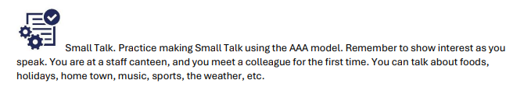

El Modelo AAA (Ask, Answer, Add)
Para mantener la conversación viva, sigue este ciclo:
- Ask (Preguntar): Haz una pregunta abierta.
- Answer (Responder): Responde a la pregunta que te hicieron.
- Add (Agregar): Añade información extra (un comentario, una opinión o una experiencia) para darle "gancho" a la otra persona y que pueda seguir hablando.

Preguntas Disparadoras
Aquí tienes una lista categorizada para evitar quedarte en blanco:
- Trabajo: "How are you finding your first week here?" / "What are you working on at the moment?"
- Lugar/Ciudad: "Have you lived in [ciudad] for a long time?" / "What do you like most about this area?"
- Tiempo libre/Hobbies: "Do you have any plans for the weekend?" / "What do you usually do to relax after work?"
- Viajes: "Have you been on holiday recently?" / "What is the best place you have ever visited?"
- Clima/Entorno: "It's really nice weather today, isn't it?" / "How is the food here at the canteen?"

Ejemplo de Conversación (Aprox. 3 minutos)
Persona A: Hi! I am Mateo. Are you new here?
Persona B: Hi Mateo! Yes, I am [Nombre]. Nice to meet you.
Persona A: Nice to meet you too! How are your first days?
Persona B: They are great! Everyone is very nice. I am working in the IT department now.
Persona A: Oh, IT! That is interesting. I am in Sales. Are you from Mar del Plata?
Persona B: No, I am from Córdoba. I moved here one month ago. And you?
Persona A: I am a local. I love the beach! Do you like the beach or the mountains?
Persona B: I love the beach! I want to walk by the sea. Do you know a good coffee shop?
Persona A: Yes! There is a great place near here. We could go together during the break. What do you think?
Persona B: ITs a good idea, i love the coffe, do you like it or do you prefer mate?
Persona A: I like both, but today i want a big coffe. In the night we will go with my partners to FIchin, its a very good bar in the center, do you want to come with us?
Persona B: Yes!!! I want to meet new people.
Persona A: Excelent, see you later.

IT PROBLEMS
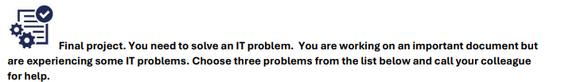

Vocabulario Clave para IT Problems
- Log on / Sign in: Iniciar sesión.
- Log off / Sign out: Cerrar sesión.
- System crash: El sistema se colgó/cayó.
- Frozen screen: Pantalla congelada.
- Error message: Mensaje de error.
- Access denied: Acceso denegado.
- To run a program: Ejecutar un programa.
- To reboot / restart: Reiniciar.
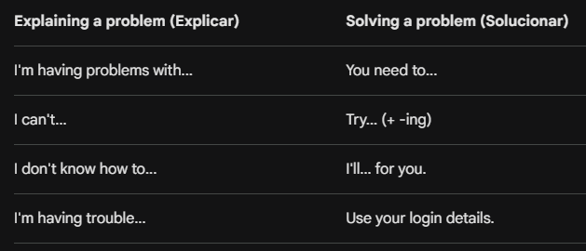

Ejemplo de Conversación (Aprox. 3 minutos)
Contexto: Llamas a un colega (técnico) porque tienes 3 problemas.

Tú: Hi [Nombre], could you help me? I’m working on a report and I’m having some problems. Do you have a minute?
Colega: Sure, what’s going on?

Tú (Problema 1): First, I can't connect to the intranet. It says "Access Denied", so I can't see my files.
Colega: That's strange. Try logging on again with your new password.

Tú (Problema 2): I already did, but now my screen is frozen. I can't open my email.
Colega: Okay, you need to reboot your computer. Sometimes that fixes the connection.

Tú (Problema 3): Right. And one more thing: I can't find my extension number Can you help me?
Colega: Ok, I'll check the system and I'll set that up for you.

Tú (Cierre/Checking): That’s great! So, just to check, I reboot the computer and you check the extension, right?
Colega: Exactly.
Tú: Thanks you for your help! Bye!

FORMAL EMAIL
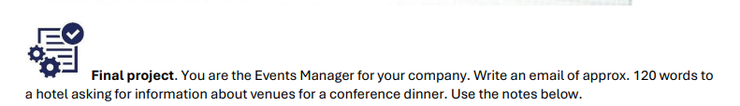

Características de un Email Formal
- Greeting (Saludo): Si conoces el nombre, usa "Dear Mr./Ms. [Apellido],". Si no, usa "Dear Sir/Madam,".
- Reason for writing (Motivo): Ve directo al grano. "I am writing to enquire about..." o "I am writing to request information regarding...".
- Concisión: Sé breve. Usa párrafos cortos.
- Vocabulario específico: Evita contracciones (I am en lugar de I'm, do not en lugar de don't).
- Closing (Despedida): Usa frases estándar como "I look forward to hearing from you" antes de la firma.
- Signature (Firma): "Kind regards," o "Yours sincerely," seguido de tu nombre y cargo.

Ejemplo de Conversación (Aprox. 3 minutos)
Subject: Inquiry regarding venue for company anniversary dinner
Dear Sir/Madam,
I am writing to enquire about hosting our company’s 10th-anniversary celebration at your hotel. We are expecting 200 guests and require a venue that can accommodate this number comfortably.
We are looking for a space that offers the following:
- A garden area for drinks and snacks upon arrival.
- A main hall with round tables for 10–12 people each.
- A three-course meal, including specific vegetarian and vegan options.
- A stage for a live band and enough space for dancing.
- A high-quality sound system and microphones for speeches.
Could you please confirm if you have availability for this event? Furthermore, could you provide information regarding the best price per person for this type of package?
I look forward to hearing from you soon.
Kind regards,
[Tu Nombre] Events Manager
INFORMAL EMAIL

Características de un Informal Email
- Greeting (Saludo): Informal. Puedes usar "Hi [Nombre]," o incluso "Hey [Nombre],".
- Contractions (Contracciones): Aquí sí debes usarlas (ej. I'm, can't, don't, I'll) para que suene natural.
- Language (Lenguaje): Menos estructurado. Puedes usar frases más coloquiales y menos rígidas que en un correo formal.
- Phrasing (Fraseo): Se permiten exclamaciones y preguntas directas sin tanta formalidad.
- Closing (Despedida): "Best," "Cheers," o "See you soon," seguido de tu nombre solo (sin cargo ni firma larga).
Ejemplo de Conversación (Aprox. 3 minutos)
Subject: 10th anniversary party!
Hi Sarah,
How’s it going? I'm starting to plan our company’s 10th-anniversary party, and I could really use your help. We’re expecting about 200 people, so it’s going to be a pretty big event!
I’m looking for a venue where we can have drinks in the garden first, and then move inside for a three-course dinner. We’ll need round tables for 10-12 people each, a good spot for a band, and a decent sound system for the speeches.
Do you know any cool places that could handle a crowd like that? Let me know what you think when you have a sec!
Cheers,
[Tu Nombre]
CHECKING AND CLARIFYING

1. Resumen de Vocabulario (Funciones)
Para dominar esta parte, debes distinguir cuándo estás verificando (comprobando si entendiste bien) y cuándo estás clarificando (pidiendo que te expliquen mejor).
- Para verificar (Checking):
  - So, if I understand correctly... (Entonces, si entiendo correctamente...)
  - So, what you’re saying is... (Entonces, lo que estás diciendo es...)
  - Let me just confirm that... (Déjame confirmar que...)
  - Are you saying that...? (¿Estás diciendo que...?)
- Para clarificar (Clarifying):
  - Could you explain what you mean by...? (¿Podrías explicar qué quieres decir con...?)
  - Could you give me an example of that? (¿Podrías darme un ejemplo de eso?)
  - Sorry, I didn't quite catch that. Could you repeat it? (Perdón, no entendí bien. ¿Podrías repetirlo?)
  - What do you mean by [término]? (¿Qué quieres decir con...?)

2. Preguntas Clave para tu examen
Basado en el ejercicio 7A, estas son las estructuras que suelen evaluarse:
- Confirmación de detalles: "So, just to confirm, you want someone with...?"
- Verificación de presupuestos/condiciones: "And could I just clarify, you’re looking for someone with...?"
- Pregunta sobre una suposición: "So, you want to hire someone locally, is that right?"
- Manejo de temas sensibles: "What do you mean by 'sensitive topic'?"
- Verificación geográfica: "There is an airport near the office, isn't there?"

Ejemplo de Conversación (Aprox. 3 minutos)
Persona A: We need to organize the team meeting. I think morning is better.
Persona B (Checking): So, you mean having the meeting in the morning, not in the afternoon?
Persona A: Yes, people are more focused in the morning.
Persona B (Clarifying): What time do you mean exactly? Early morning or mid-morning?
Persona A: Around 10 a.m.
Persona B (Checking): If I understand correctly, the meeting will start at 10 a.m., right?
Persona A: Yes.
Persona B (Clarifying): And how long should it be?
Persona A: Not too long, about 30 minutes.
Persona B (Checking): So, just to confirm: a 30-minute meeting at 10 a.m.?
Persona A: Exactly.
Persona B (Clarifying): Should everyone attend, or just the managers?
Persona A: Only the team leaders.
Persona B (Checking): Got it: only team leaders, 10 a.m., 30 minutes?
Persona A: Perfect. That is exactly what I need.

ORGANIZING A MEETING
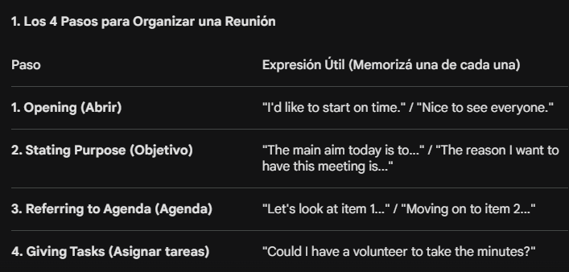

Vocabulario Esencial (Fill-in-the-blanks)
Basado en tus ejercicios, estas son las palabras clave que tenés que saber ubicar:
- Aim: El objetivo principal.
- Agenda: La lista de temas a tratar.
- Volunteer: Alguien que se ofrece para una tarea.
- Minutes: El resumen escrito de lo que se habló (acta).
- Moving on to...: Frase clave para cambiar de tema.
- Go back to...: Frase para volver a un tema anterior.

Ejemplo de Conversación (Aprox. 3 minutos)
Tú (Opening): Hi everyone! Let’s start so we can finish on time.
Compañero: Hi! Sounds good.
Tú (Stating Purpose): Today we need to plan our next marketing campaign.
Compañero: Okay, what do we start with?
Tú (Referring to Agenda): First, the budget. Can someone take notes?
Compañero: I can do it.
Tú (Organizing): Great, thanks. Do you have the agenda?
Compañero: Yes, I have it. The budget looks a bit low,.
Tú (Checking): So, you think we need a bigger budget?
Compañero: Yes, especially for ads.
Tú (Moving on): Okay, let’s move to social media.
Compañero: I think we should post more videos and be more active.
Tú (Checking): So, more video content and more frequent posts?
Compañero: Exactly.
Tú (Closing): Great. Before we finish, let’s go back to the budget for a second.
Compañero: Sure, maybe we can adjust it there.

